Date & Time Functions

______________________________________________________________________________

Problem Statement:

You are a Data Analyst at Amazon Fresh. You have been tasked to study the Farmer’s Market.

Dataset: Farmer’s Market database

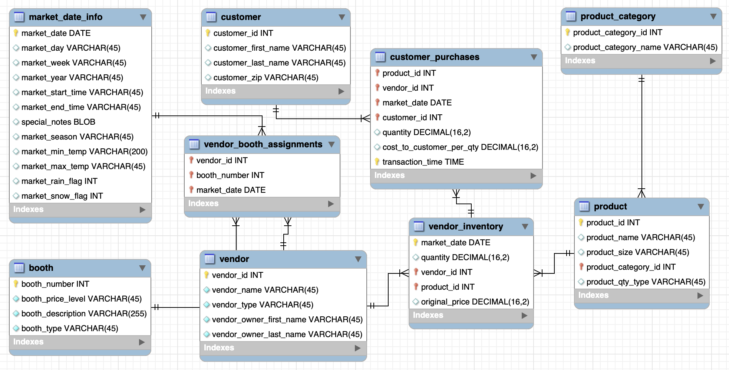

______________________________________________________________________________

# So far…

* You now know how to aggregate data, group data, use JOINs to get data from multiple tables and how to do windowed calculations

But

* We haven’t dealt with date and time data type. One of the most important and common problems for data scientists is dealing with temporal data.
* Many **ML algorithms are “trained” to identify patterns in data** from the past and use those patterns to predict future outcomes. In order to build a dataset for that purpose, we have to be able to filter queries by time range.
* Often, datasets that are built for predictive models include summaries of activities within dynamic date ranges—for example, **how many times a user ordered an iPhone on Amazon during each of the past three months.**
* Or, in the case of time-series analysis, an input dataset might include one row per time period (hour, day, week, month) with a count of something associated with each time period; for example, the number of patients a doctor sees per week.

In our database, I have created one more table called [**datetime_demo**](https://drive.google.com/file/d/1vmPuF0K1onScjDOaYfVyj8tAq2KqmGbI/view?usp=sharing)to showcase how you can work with datetime data types.

Inside this table,

* We have data from the “**market_date_info**” table i.e. market_date, market_start_time, and market_end_time columns.

Along with two additional columns **market_start_datetime** and **market_end_datetime**.

Here’s what the “**datetime_demo**” table looks like:

SELECT * FROM farmers_market.datetime_demo;

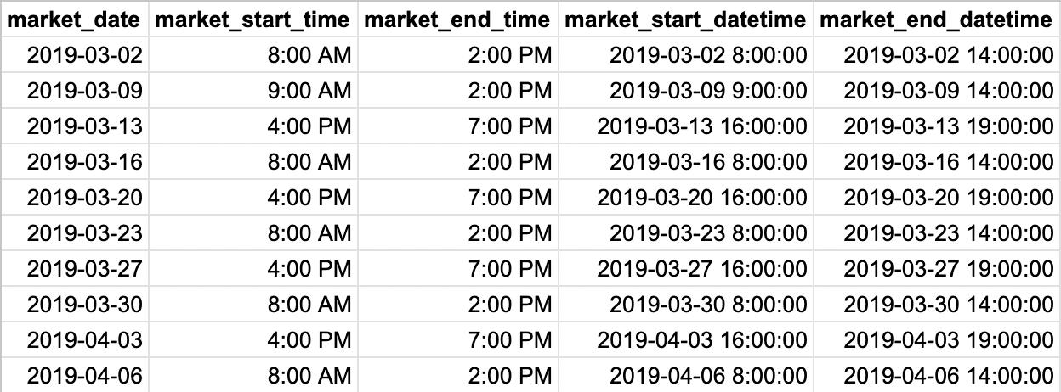

______________________________________________________________________________

**DateTime format -**

Previously, we saw that

* the market date was in “YYYY-MM-DD”,
* the market start and end time were in “hr:mins AM/PM”, and
* the market start and end datetime in “YYYY-MM-DD HH:MM:SS” format.

But do we always get date and time in the same format?

No, it might differ when working on different data based on how the DateTime format is saved.

Let us have a look at some of the commonly used DateTime formats:

* %Y: Year with century (e.g., 2023)
* %m: Month (01-12)
* %d: Day of the month (01-31)
* %I: Hour (00-12)
* %H: Hour (00-23)
* %M: Minute (00-59)
* %S: Second (00-59)
* %P: AM/PM

____________________________________________________________________________

Oftentimes, you will encounter datetime data types, such as timestamps, in the databases you work with and might only need a portion of the stored date and time value.

Let’s answer a few questions to understand:

## **EXTRACT()**

Question: Suppose you wish to know from which year to which year data do we have in our database?

To extract the year, in MySQL, we can use the EXTRACT() function.

**For BigQuery:**

SELECT

MIN(EXTRACT(year

FROM

market_start_datetime)) AS min_year,

max (EXTRACT(year

FROM

market_start_datetime)) AS max_year

FROM

`farmers_market.datetime_demo`;

______________________________________________________________________________

Question: What if you only want to see the hour at which the market started and ended on each date?

**For BigQuery:**

SELECT

EXTRACT(hour

FROM

market_start_datetime) AS start_hr,

EXTRACT(hour

FROM

market_end_datetime) AS end_hr

FROM

`farmers_market.datetime_demo`;

______________________________________________________________________________

Similarly, we can extract the followings from each ‘market_start_datetime’ as well -

* Date
* Time
* Year
* Quarter
* Month
* Day
* Week
* Day Of Week
* Hour
* Minute
* Second

Here’s how the syntax goes:

**For BigQuery:**

SELECT market_start_datetime,

EXTRACT(date from market_start_datetime) as date,

EXTRACT(time from market_start_datetime) as time,

EXTRACT(year from market_start_datetime) as year_no,

EXTRACT(quarter from market_start_datetime) as q_no,

EXTRACT(month from market_start_datetime) as month_no,

EXTRACT(day from market_start_datetime) as day_no,

EXTRACT(week from market_start_datetime) as week_no,

EXTRACT(DAYOFWEEK from market_start_datetime) as week_day,

EXTRACT(hour from market_start_datetime) as hr,

EXTRACT(minute from market_start_datetime) as minute,

EXTRACT(second from market_start_datetime) as second,

FROM farmers_market.datetime_demo

**Note:** Depending on the database system you are using, the function that retrieves different portions of a datetime value may be called EXTRACT (MySQL), DATE_ PART (Redshift), or DATEPART (Oracle and SQL Server).

______________________________________________________________________________

Question: Your manager asks you that for each market date, he wants to see what day & month it was. Display the name of the day & month.

**For BigQuery:**

SELECT

market_start_datetime,

**FORMAT_DATETIME**("%B", market_start_datetime) as mktsrt_month_name,

**FORMAT_DATETIME**("%A", market_start_datetime) as   
mktsrt_day_name

FROM

`farmers_market.datetime_demo`

______________________________________________________________________________

## **DATE() AND TIME()**

Question: Suppose you only have the ‘market_start_datetime’ column in the table and you want to view the **date** and **time** fields separately.

We also have shortcuts for extracting the entire **date** and entire **time** from the datetime field, so you don’t have to extract each part and re-concatenate it together.

**For BigQuery:**

SELECT

market_start_datetime,

**DATE**(market_start_datetime) AS mktsrt_date,

**TIME**(market_start_datetime) AS mktsrt_time

FROM

`farmers_market.datetime_demo`

______________________________________________________________________________

## **DATE_ADD and DATE_SUB**

The powerful thing about storing string dates as datetime values (or converting them using SQL) is that you can do date calculations, which is not possible when they are stored as numbers, punctuation, and letters in a string field.

Here, we’ll use the **market_start_datetime** and **market_end_datetime** fields to demonstrate.

**The DATE_ADD() function adds a time/date interval to a date and then returns the date.**

We can use SQL to add 30 minutes to the start time by passing the datetime, the interval (minutes, in this case), and the number of minutes we want to add into the DATE_ADD function:

SELECT market_start_datetime,

DATE_ADD(market_start_datetime, INTERVAL 30 MINUTE) AS mktstrt_date_plus_30min

FROM farmers_market.datetime_demo;

Note:

* If we instead wanted to do a calculation that required **looking 30 days past a date** (for example which would require calculating 30 days past a customer’s first purchase to determine if they made a second purchase within that time frame), we could change the interval parameter from MINUTE to DAY, and add 30 days instead:

SELECT market_start_datetime,

DATE_ADD(market_start_datetime, INTERVAL 30 DAY) AS mktstrt_date_plus_30days

FROM farmers_market.datetime_demo;

**There is also a related function called DATE_SUB() that subtracts intervals from datetimes.**

However, instead of switching to DATE_SUB(), you could also just add a **negative number** to the datetime if you prefer.

The following query demonstrates that using DATE_ADD() to add **–30 days** to a date has the same effect as using DATE_SUB() to subtract 30 days from a date,

SELECT market_start_datetime,

DATE_ADD(market_start_datetime, INTERVAL -30 DAY) AS mktstrt_date_

plus_neg30days,

DATE_SUB(market_start_datetime, INTERVAL 30 DAY) AS mktstrt_date_

minus_30days

FROM farmers_market.datetime_demo;

______________________________________________________________________

## **DATE_DIFF()**

Question: Find the number of days between the first and last market dates.

DATE_DIFF is a SQL function available in BigQuery that accepts two dates or DateTime values along with a **date_part** and **returns the difference between them** specified date_part intervals.

**For BigQuery:**

SELECT

x.first_market,

x.last_market,

DATE_DIFF(x.last_market, x.first_market, DAY) days_first_to_last

FROM

(

SELECT

min(market_start_datetime) first_market,

max(market_start_datetime) last_market

FROM farmers_market.datetime_demo

) x

Here, the inner query (by which I mean the query inside parentheses, aliased “x”) returns the first and last market dates from the **datetime_demo** table, and the outer query (which is selecting from “x”) calculates the difference between those two dates in days using DATE_DIFF.

____________________________________________________________________________

Question: But what if we want the difference between the first and last market dates in hours instead of days?

The **DATE_DIFF** function is used only for date values, but there is also a function in BigQuery called **TIMESTAMP_DIFF** that returns the difference between two datetimes in any chosen interval.

Here, we calculate the **hours** and **minutes** between the **market start and end times** on each market date.

**For BigQuery:**

SELECT market_start_datetime, market_end_datetime,

TIMESTAMP_DIFF(market_end_datetime, market_start_datetime ,HOUR)

AS market_duration_hours,

TIMESTAMP_DIFF(market_end_datetime,market_start_datetime, MINUTE)

AS market_duration_mins

FROM farmers_market.datetime_demo;

____________________________________________________________________________

## **PARSE_DATETIME()**

Let’s have a look at the **transaction_time** column in the “**customer_purchases**” table.

SELECT transaction_time FROM farmers_market.customer_purchases;

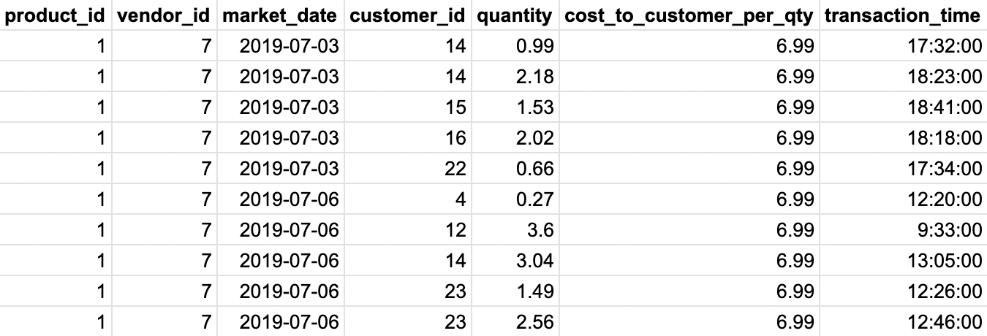

**Observation:** Notice that the transaction_time is **24hr** format compared to **12hr** format in market_start_time and market_end_time.

Question: Create a new column **market_date_trans_time** that contains market date and transaction time in a proper **datetime** format.

**For BigQuery:**

SELECT *,

**PARSE_DATETIME**("%Y-%m-%d %H:%M:%S", CONCAT(market_date," ", transaction_time)) AS market_date_trans_time

FROM farmers_market.customer_purchases;

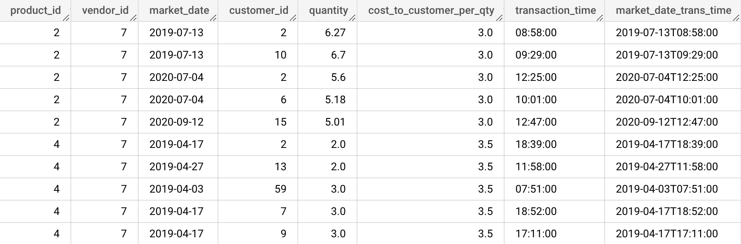

* PARSE_DATETIME("%Y-%m-%d %H:%M:%S", CONCAT(market_date," ", transaction_time)):
  + This function combines the values from the market_date and transaction_time columns, concatenating them into a single string with the format "YYYY-MM-DD HH:MM:SS".
  + It then parses this string into a datetime value using the specified format.
* %Y-%m-%d %H:%M:%S is the format used to describe how the datetime string should be interpreted.
  + It breaks down as follows:
    - %Y: Year with century (e.g., 2023)
    - %m: Month (01-12)
    - %d: Day of the month (01-31)
    - %H: Hour (00-23)
    - %M: Minute (00-59)
    - %S: Second (00-59)

____________________________________________________________________________

**Complex Question:** Let’s say you want to calculate how many sales occurred within the first 30 minutes after the farmer’s market opened, how would you dynamically determine what cutoff time to use? (automatically calculate it for every market date in your database)

Again, this is where **DATE_ADD** and **PARSE_DATETIME** functions come in.

For BigQuery:

SELECT

market_date,

COUNT(*) AS num_sales

FROM (

SELECT

c.market_date,

time(PARSE_DATETIME('%I:%M %P', m.market_start_time)) AS market_start_time,

time(PARSE_DATETIME('%I:%M %P', m.market_end_time)) AS market_end_time,

time(c.transaction_time) AS transaction_time, PARSE_DATETIME('%Y-%m-%d %I:%M %P', CONCAT(c.market_date, " ", m.market_start_time )) AS market_start_datetime,

PARSE_DATETIME('%Y-%m-%d %I:%M %P', CONCAT(c.market_date, " ", m.market_end_time )) AS market_end_datetime,

PARSE_DATETIME('%Y-%m-%d %H:%M:%S', CONCAT(c.market_date, " ", c.transaction_time )) AS market_date_transaction_time,

c.product_id,

c.vendor_id,

c.customer_id,

c.quantity,

c.cost_to_customer_per_qty

FROM farmers_market.customer_purchases c

LEFT JOIN farmers_market.market_date_info m

ON c.market_date = m.market_date)

WHERE market_date_transaction_time <= DATE_ADD(market_start_datetime, INTERVAL 30 MINUTE)

GROUP BY market_date

ORDER BY market_date;

____________________________________________________________________________

## **Date Functions in Aggregate Summaries and Window Functions :-**

In this section, we’ll explore a few ways that you can use date functions when **summarizing** data.

## Question: Let’s say we wanted to get a profile of each farmer’s market customer’s habits over time.

* First purchase date
* Last purchase date
* Count of distinct purchases

Q1. If we wanted to determine for how long this person has been a customer of the farmer’s market?

We can get the **difference between the first and last purchase**.

**For BigQuery:**

SELECT customer_id,

MIN(market_date) AS first_purchase,

MAX(market_date) AS last_purchase,

COUNT(DISTINCT market_date) AS count_of_purchase_dates,

DATE_DIFF(MAX(market_date), MIN(market_date), day) AS days_between_first_last_purchase

FROM farmers_market.customer_purchases

GROUP BY customer_id

Q2. If we wanted to also know how long it’s been since the customer last made a purchase?

We can use the **CURRENT_DATE**() function.

**CURRENT_DATE()** can be used to represent the current system date in any calculation that requires a date or datetime parameter.

**For BigQuery:**

SELECT customer_id,

MIN(market_date) AS first_purchase,

MAX(market_date) AS last_purchase,

COUNT(DISTINCT market_date) AS count_of_purchase_dates,

DATE_DIFF(MAX(market_date), MIN(market_date), day) AS days_between_first_last_purchase,

DATE_DIFF(CURRENT_DATE(), MAX(market_date), day) AS days_since_last_purchase

FROM farmers_market.customer_purchases

GROUP BY customer_id

____________________________________________________________________________

**With Window Functions :-**

## Question: Write a query that gives us the days between each purchase a customer makes.

Step 1: How can we get the previous purchase? - LAG()

SELECT customer_id,

market_date,

LAG(market_date,1) OVER (PARTITION BY customer_id ORDER BY market_

date) AS last_purchase

FROM farmers_market.customer_purchases;

Step 2: How to get the no. of days between current and the last purchase date? - DATE_DIFF()

SELECT

customer_id,

market_date,

LAG(market_date, 1) OVER (PARTITION BY customer_id ORDER BY market_date) AS last_purchase,

DATE_DIFF(market_date, (LAG(market_date, 1) OVER (PARTITION BY customer_id ORDER BY market_date)), DAY) AS count_bw_prchs

FROM farmers_market.customer_purchases;

* Here, we didn’t quite accomplish the goal of finding the difference between each purchase date and the previous purchase date.
* Because there are multiple rows with the same date in cases where the customer purchased multiple items on the same date.

We can resolve this in a few ways.

* One approach is to remove the duplicates by using the DISTINCT keyword, and then use a WHERE clause filter to remove rows where the two dates (current and next purchase) are the same (because multiple purchases were made on the same date).
* Another is to remove duplicates in the initial dataset and use a subquery (a query inside a query) to get the date differences. Doing this and moving the window functions to the outer query will also fix the issue of the RANK counting each purchase, when we really want to count each purchase date.

**For BigQuery:**

SELECT

x.customer_id,

x.market_date,

LAG(x.market_date, 1) OVER(PARTITION BY x.customer_id ORDER BY x.market_date) AS last_prchs,

DATE_DIFF(x.market_date, LAG(x.market_date, 1) OVER(PARTITION BY x.customer_id ORDER BY x.market_date), DAY) AS days_bw_prch

FROM

( SELECT

DISTINCT customer_id,

market_date

FROM farmers_market.customer_purchases

) AS x

____________________________________________________________________________

## Question: Today’s date is May 31, 2019, and the marketing director of the farmer’s market wants to give infrequent customers (with only 1 purchase) an incentive to return to the market in April.

Pull up a list of everyone who only purchased once during the previous month, because they want to email all of those customers with a coupon to receive a discount on a purchase made in April.

* First, we must find everyone who made a purchase 31 days prior to May 31, 2019.
* Then, we need to filter that list to those who came to the market and made purchase(s) on a single market date.

This query would retrieve a list of one row per market date per customer within that date range:

**For BigQuery:**

SELECT DISTINCT customer_id, market_date

FROM farmers_market.customer_purchases

WHERE DATE_DIFF('2019-05-31', market_date, DAY) <= 31

Then, we could query the results of that query, **count the distinct *market_date* values** per customer during that time, and **filter to those with exactly one market date**, using the HAVING clause.

**For BigQuery:**

SELECT x.customer_id,

COUNT(x.market_date) AS market_count

FROM (

SELECT DISTINCT customer_id, market_date

FROM farmers_market.customer_purchases

WHERE DATE_DIFF('2019-05-31', market_date, DAY) BETWEEN 0 AND 31

) x

GROUP BY x.customer_id

HAVING COUNT(DISTINCT market_date) = 1

____________________________________________________________________________